Current CSS Code:

background-image: linear-gradient(to right top, #d16ba5, #c777b9, #ba83ca, #aa8fd8, #9a9ae1, #8aa7ec, #79b3f4, #69bff8, #52cffe, #41dfff, #46eefa, #5ffbf1);

BACKGROUND GENERATOR

This project aims to find the best-looking background gradient for your project. You just have to select the colors you want from the color picker and then copy the code displayed and paste it into your code as a background color. It’s That Simple!

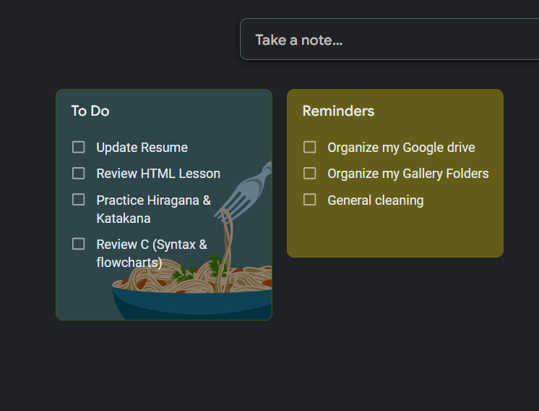

This is a common project that all web developers have done at least once in their lifetime. Not only will this help you to keep track of your daily tasks but is a good project too at least at the beginner level. You can connect it with a database to store the daily tasks, the benefit of storing daily tasks in a database will be, you can, later on, add delete functionality to it. If a user by mistake deletes a todo, you can give the privilege to restore it.



The cooking recipe database project idea is an intermediate-level SQL project that you can opt for. You can choose to design the web portal to portray your recipes under different categories. You can input details like the last viewed recipe, a recipe of the day, and a recipe blog with the help of HTML or RichText. Furthermore, you can incorporate a rating functionality that lets users rate recipes and leave comments.

**Features needed –** You can enhance things by introducing functionality for rating and leaving comments on each recipe by users.